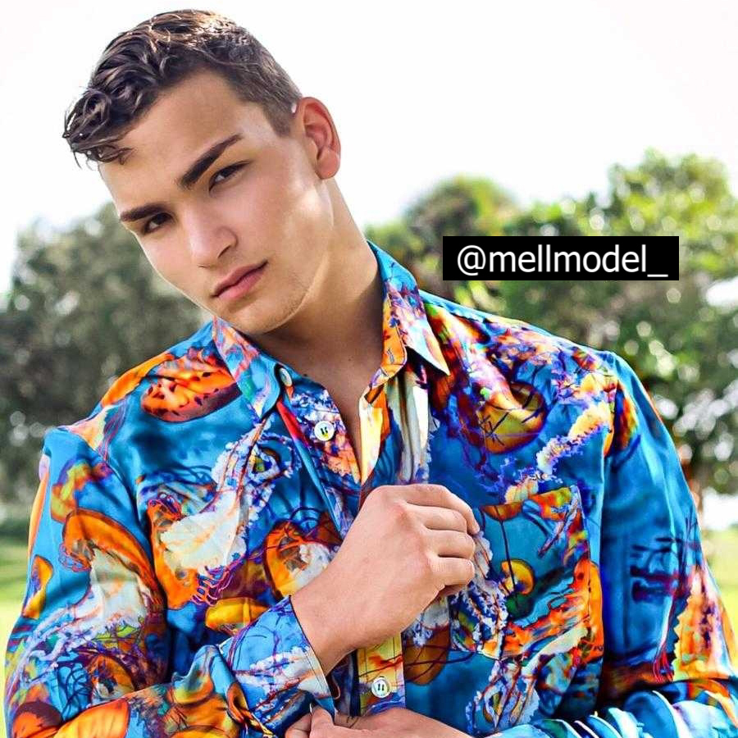 |  | EDUCATION
Miami Media School –Miami, FL
03-01-2018 to 11-01-2019
Hispanic Media Broadcasting

South Miami Senior High School – Miami, FL
01-08-2016 – 05-18-2018
High School Diploma

Set Sistema Educativo de talento – Mexico, Monterrey
01-23-2015 – 07-31-2016
Production and Hosting of Audiovisual Media

Mell gonzalez  Fashion Model, Actor and TV/Radio Personality  Profile  Professional Bilingual person with extensive work experience in the media industry. Excellent communication, reliability, organizational, and multi-tasking skills. Able to perform well under pressure and meet deadlines individually or as part of a team. Looking for the opportunity of assisting your company to increase its revenues and ratings.  CONTACT  PHONE:  786-344-7892  Social Media  LinkedIn  www.linkedin.com/in/mellmodel  Facebook  https://www.facebook.com/mellgonzalezborrego  EMAIL:  gonzalezborregomell@gmail.com |  | WORK EXPERIENCE
2017–Present – USA, Miami
-Caso Cerrado Capitulo Odor Dating como testigo

-Betty en New York cap 10

-Premios Juventud 2019 role model who give the awards to winners

-Miami Swim Week 2019 I walk for two famous brand

-Music Video for Myke Towers, Becky G, Farruko, Arcangel, Sech, Zion and Lenox

2014–2016 - Mexico, Monterrey
Acabatelo, Multimedios TV (TV Personality)
-Production Assistant, Dancer, Entertaining Person

Vampiros en La Habana Movie
Voice overs for several characters voices

2015-2020 (working for)
Networks: Telemundo, Univision, Multimedios Tv, Fashion Tv

Brands:,Adidas,Heineken, Iberostar, Nestle, Lexus, Moet, MistertripleX, Argyle Grant, Acidnewyork, Christian Colorado

Artists: Myke Towers, Becky G, Farruko, Arcangel, Sech, Zion and Lenox

 |  | SKILLS
1 | On- Air talent
2 | Blogging
3 | Podcasting
4 | Microsoft Office, Word, PowerPoint, Excel , Outlook
5 | Bilingual English&Spanish
6 | Web content development

