 | 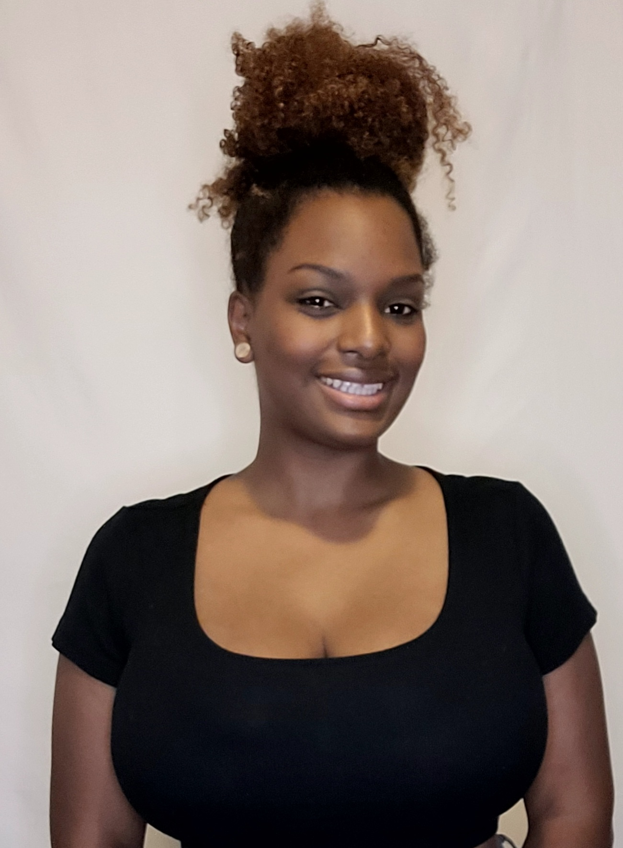 |  | Chande pinkney  Independent contractor  EDUCATION  The Art institute of Washington  2012 - 2014  AA of Art and Design with Concentration in Social Engineering  Overview  As a Brand Ambassador, I have had the pleasure of cultivating skills that allow me success in several of my personal ventures and professional projects. Throughout many past events, I have been tasked with crucial roles, such as direct customer engagement for marketing purposes as well as registration and engagement with high profile clients. I pride myself in my stoic professionalism in all of my work. As a promoter and event coordinator, I organized strategies for increasing user engagement with innovative solutions. The following are some of the projects and organizations I have had the pleasure of working on and for  WORK EXPERIENCE  Just Ask LLC- 2016 print model  - AIPAC Policy Conference- 2017& 2018 event ambassador  - Microsoft Inspire Tradeshow- 2017 registration/ room attendant  - Juventus tour- 2018 street team  - American Academy of Dermatology- 2019 tradeshow exhibitor  - Kaiser Permanente- 2019 street team  - Samsung Galaxy Tour- 2019 device specialist/ registration/ marketing/ street team  - Cash App- 2019 marketing/ promotions  - Prestige Catering- 2019 banquet server  - CIvil Cigar Lounge- 2019 cocktail server  - Pepsi Cola- 2019 product specialist/ promotions  - American Library Association- 2019 newspaper distribution  - Giant BBQ battle- 2019 promotional model/ marketing  - Rise of the Teenage Mutant Ninja Turtles- 2019 mascot  - Sprint 5G Campaign- 2019 street team  - BluSage Catering- 2019 buffet attendant  - Givesmart- charity fundraiser digital auctions registration 2017-2022  - Ali Wong Comedy Show- 2021 Yonder phone security  - Line Friends BT21 Popup Store- 2022 sales and marketing  - Chandon Garden Spritz- 2022 on and off premise alcohol sampling  - Goldman Sachs 10K Small Businesses- 2022 brand ambassador  - Envision Junior Young leaders-2022 greeter/registration  - Propel Water "Propel Into Fitness"- 2022 product sampling/street team  - George Washington University Graduation- 2022 full service bartender  - Wells Fargo Golf Championship- 2022 keynote speaker/ brand ambassador  - Richmond Nascar- 2022 Cheese itz Brand Ambassador  - Late Night at Safeway- 2022 product specialist/ product demons  - Life Water, Howard University Freshmen welcome party- 2022 Brand Ambassador  - ASOS Tour DC- 2022 surveyer, Brand ambassador, Promo Staff  - Indeed Ready for Work- 2022 Brand Ambassador  - Meridian Capital Corporate Party- 2022 Registration  - Pepsi, CIA Family Day- 2022 pop-a-shot basketball game attendant  - Taiwan Excellence Expo- 2022 Brand Ambassador, product specialist  - Pepsi Wagon Walmart tour- 2022 Brand Ambassador, Tour Lead, Food Handler  - Dunkin Wonderland Tour- 2022 Brand Ambassador  SKILLS  Organization  Verbal communication  Interpersonal skills  Social media engineering  Creative promotions  Conflict resolution  Brand awareness  Customer service  Registration  Marketing strategies

Profile
A company’s image is one of its greatest strengths as well as its greatest weakness in today’s ever-changing social marketplace. I personally believe that it is my job as your brand ambassador of quality, confidence and care to exemplify an understanding and prioritization of that assurance.

CONTACT
PHONE:
240-475-6026

EMAIL:
Chandepinkney@yahoo.com

references
Contacts provided upon request
Kanayo Oke
Toni Benbow
Kenneth Johnson

